PL/SQL Programming

Question:1
CREATE TABLE Customers (
CustomerID INT PRIMARY KEY,
CustomerName VARCHAR(100),
Age INT,
Balance DECIMAL(10,2),
IsVIP BOOLEAN DEFAULT FALSE
);
CREATE TABLE Loans (
LoanID INT PRIMARY KEY,
CustomerID INT,
LoanAmount DECIMAL(10,2),
InterestRate DECIMAL(5,2),
DueDate DATE,
FOREIGN KEY (CustomerID) REFERENCES Customers(CustomerID)
);
INSERT INTO Customers VALUES
(1, 'John', 65, 12000, FALSE),
(2, 'Alice', 45, 8000, FALSE),
(3, 'Robert', 70, 15000, FALSE);

INSERT INTO Loans VALUES
(101, 1, 50000, 10.00, '2026-07-15'),
(102, 2, 30000, 12.00, '2026-08-20'),
(103, 3, 40000, 11.00, '2026-07-10');
-- Scenario 1
UPDATE Loans l JOIN Customers c
ON l.CustomerID = c.CustomerID
SET l.InterestRate = l.InterestRate - 1
WHERE c.Age > 60;

SELECT * FROM Loans;
-- Scenario 2
UPDATE Customers
SET IsVIP = TRUE
WHERE Balance > 10000;

SELECT * FROM Customers;
-- Scenario 3

SELECT
CONCAT(
'Reminder: Dear ',
c.CustomerName,
', your Loan ID ',
l.LoanID,
' is due on ',
DATE_FORMAT(l.DueDate,'%d-%b-%Y')
) AS Reminder_Message
FROM Customers c
JOIN Loans l
ON c.CustomerID = l.CustomerID
WHERE l.DueDate BETWEEN CURDATE() AND DATE_ADD(CURDATE(), INTERVAL 30 DAY);

Output:-
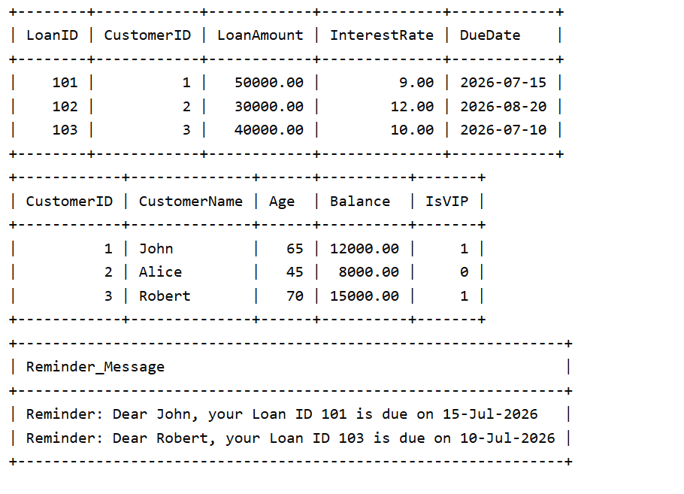

Question:3
Code:-
CREATE TABLE Accounts (
AccountID INT PRIMARY KEY,
CustomerName VARCHAR(100),
AccountType VARCHAR(20),
Balance DECIMAL(10,2)
);
INSERT INTO Accounts VALUES
(101, 'John', 'Savings', 10000),
(102, 'Alice', 'Savings', 20000),
(103, 'Robert', 'Current', 15000);

-- Scenario 1:
DELIMITER //
CREATE PROCEDURE ProcessMonthlyInterest()
BEGIN
UPDATE Accounts
SET Balance = Balance + (Balance * 0.01)
WHERE AccountType = 'Savings';
END //

DELIMITER ;
CALL ProcessMonthlyInterest();
-- Scenario 2:
CREATE TABLE Employees (
EmployeeID INT PRIMARY KEY,
EmployeeName VARCHAR(100),
Department VARCHAR(50),
Salary DECIMAL(10,2)
);

INSERT INTO Employees VALUES
(1, 'Raj', 'IT', 50000),
(2, 'Priya', 'IT', 60000),
(3, 'Amit', 'HR', 45000);

DELIMITER //

CREATE PROCEDURE UpdateEmployeeBonus(
IN dept VARCHAR(50),
IN bonusPercent DECIMAL(5,2)
)
BEGIN
UPDATE Employees
SET Salary = Salary + (Salary * bonusPercent / 100)
WHERE Department = dept;
END //

DELIMITER ;

CALL UpdateEmployeeBonus('IT', 10);

DELIMITER //

-- Scenario 3:
CREATE PROCEDURE TransferFunds(
IN fromAcc INT,
IN toAcc INT,
IN amount DECIMAL(10,2)
)
BEGIN
DECLARE bal DECIMAL(10,2);

SELECT Balance
INTO bal
FROM Accounts
WHERE AccountID = fromAcc;

IF bal >= amount THEN

UPDATE Accounts
SET Balance = Balance - amount
WHERE AccountID = fromAcc;

UPDATE Accounts
SET Balance = Balance + amount
WHERE AccountID = toAcc;

END IF;
END //

DELIMITER ;
CALL TransferFunds(101, 102, 1000);

SELECT * FROM Accounts;

Ouput:-
